IT 533
Week 1 – Source Control Assignment
Sylvester Obafunwa

Ask: Your deliverable is a Word Document containing a screenshot of Microsoft Visual Studio Code running your Hello World program successfully and the URL to your GitHub repository.

1.
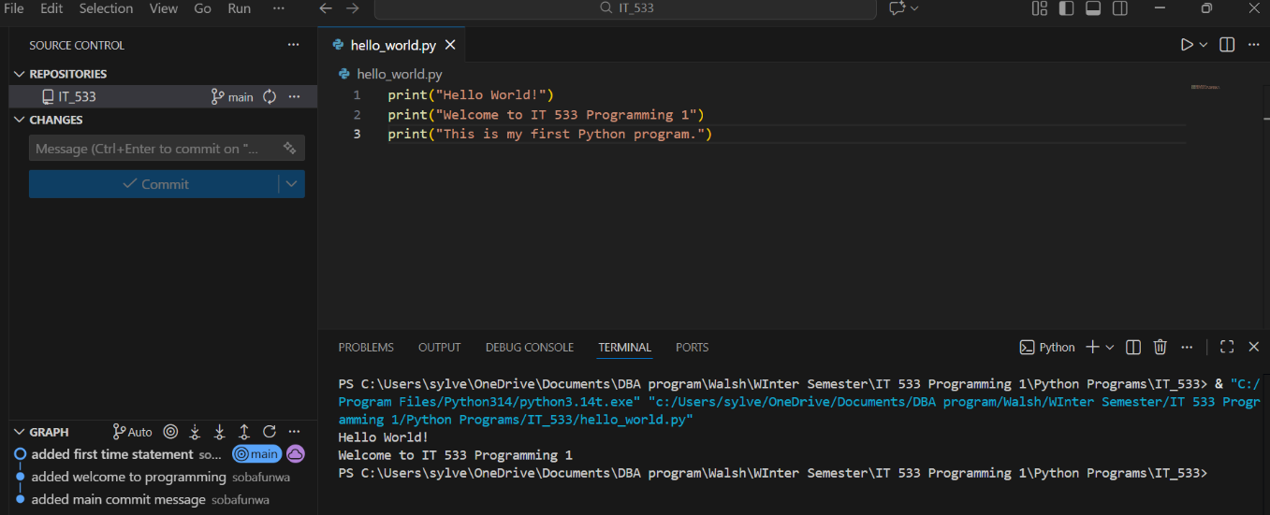

2. Sobafunwa Github repository location:
https://github.com/sobafunwa-walsh/IT_533

